Bài tập Hiện tại đơn và Hiện tại tiếp diễn

Exercise 1 (Dễ)
Put the verbs into the correct tense (simple present or present progressive).
- Look! He (leave) the house.
- Quiet please! I (write) a test.
- She usually (walk) to school.
- But look! Today she (go) by bike.
- Every Sunday we (go) to see my grandparents.
- He often (go) to the cinema.
- We (play) Monopoly at the moment.
- The child seldom (cry) .
- I (not / do) anything at the moment.
- (watch / he) the news regularly?
Đáp án
- Look! He is leaving the house.
- Quiet please! I am writing a test.
- She usually walks to school.
- But look! Today she is going by bike.
- Every Sunday we go to see my grandparents.
- He often goes to the cinema.
- We are playing Monopoly at the moment.
- The child seldom cries .
- I am not doing anything at the moment.
- Does he watch the news regularly?

Exercise 2
Complete the sentences (Simple Present or Present Progressive).
- This (be) Marc.
- He (wear) a t-shirt and shorts today.
- He (eat) an apple at the moment.
- Marc (like) fruits and vegetables.
- He (eat) some every day.
- Marc (know) that apples (be) good for his health.
- This (be) Caroline.
- Caroline (have) long blond hair.
- She usually (wear) glasses, but now she (wear) contact lenses.
- Caroline (like) sports.
- She (play) handball every Monday and Thursday.
Đáp án
- This is Marc.
- He is wearing a t-shirt and shorts today.
- He is eating an apple at the moment.
- Marc likes fruits and vegetables.
- He eats some every day.
- Marc knows that apples are good for his health.
- This is Caroline.
- Caroline has long blond hair.
- She usually wears glasses, but now she is wearing contact lenses.
- Caroline likes sports.
- She plays handball every Monday and Thursday.

Exercise 3 (Trung bình)
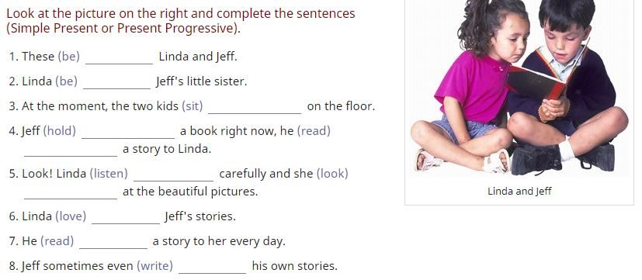
Đáp án
- These are Linda and Jeff.
- Linda is Jeff's little sister.
- At the moment, the two kids are sitting on the floor.
- Jeff is holding a book right now, he is reading a story to Linda.
- Look! Linda is listening carefully and she is looking at the beautiful pictures.
- Linda loves Jeff's stories.
- He reads a story to her every day.
- Jeff sometimes even writes his own stories.

Exercise 4 (Khó hơn)
Complete the sentences. Use Simple Present and Present Progressive.
- James (live) in a little village.
- He (be) in his last year at school.
- After school, James (want) to become a banker.
- So this week, he (do) a practical course in a bank.
- There (be) a bank in a nearby town, but James (have) to take the bus to get there.
- The bus (leave) at 5.30 in the morning and (return) at 8.15 in the evening.
- James (not / like) to spend so much time in town before and after work, waiting for the bus.
- Therefore, this week he (stay) with his aunt, who (live) in town.
- James usually (wear) jeans and t-shirts, but while he (work) for the bank now, he (wear) a suit and a tie.
- Today (be) Betty's birthday.
- Betty (love) birthdays.
- She (be) always very excited and (wake up) very early.
- At six o'clock in the morning, Betty (hear) a noise.
- She (get up) and (go) into the sitting room.
- What (go on) ?
- Look! Betty's cat Carlos (sit) on the table and he (play) with Betty's present.
- Sue (be) a student from South Korea.
- She (live) in Seoul and (study) medicine.
- At the moment, however, Sue (live) in London.
- She (do) a six-months practical course in a London hospital.
- In five days, Sue (go) back to South Korea because the next term at university (start) in ten days.
- Mary and Joe (be) in a clothes shop at the moment.
- They (look) at some jeans.
- Joe only (have) one very old pair of jeans.
- So he (want) to buy a new pair of jeans now.
- Right now, he (try on) a pair of blue jeans.
- »These jeans (fit) very well,« he (say) .
- »But they (not suit) you,« Mary (reply) . »Try on another pair.«
- »What (think / you) ?« he (ask) Mary, when has tried on another pair.
- »Great! How much (cost / they) ?«
Đáp án
- James lives in a little village.
- He is in his last year at school.
- After school, James wants to become a banker.
- So this week, he is doing a practical course in a bank.
- There is a bank in a nearby town, but James has to take the bus to get there.
- The bus leaves at 5.30 in the morning and returns at 8.15 in the evening.
- James does not like to spend so much time in town before and after work, waiting for the bus.
- Therefore, this week he is staying with his aunt, who lives in town.
- James usually wears jeans and t-shirts, but while he is working for the bank now, he is wearing a suit and a tie.
- Today is Betty's birthday.
- Betty loves birthdays.
- She is always very excited and wakes up very early.
- At six o'clock in the morning, Betty hears a noise.
- She gets up and goes into the sitting room.
- What is going on ?
- Look! Betty's cat Carlos is sitting on the table and he is playing with Betty's present.
- Sue is a student from South Korea.
- She lives in Seoul and studies medicine.
- At the moment, however, Sue is living in London.
- She is doing a six-months practical course in a London hospital.
- In five days, Sue is going back to South Korea because the next term at university starts in ten days.
- Mary and Joe are in a clothes shop at the moment.
- They are looking at some jeans.
- Joe only has one very old pair of jeans.
- So he wants to buy a new pair of jeans now.
- Right now, he is trying on a pair of blue jeans.
- »These jeans fit very well,« he says .
- »But they do not suit you,« Mary replies . »Try on another pair.«
- »What do you think?« he asks Mary, when has tried on another pair.
- »Great! How much do they cost ?«

