PHÂN BIỆT SỰ KHÁC NHAU GIỮA THÌ HIỆN TẠI ĐƠN, HIỆN TẠI TIẾP DIỄN VÀ HIỆN TẠI HOÀN THÀNH
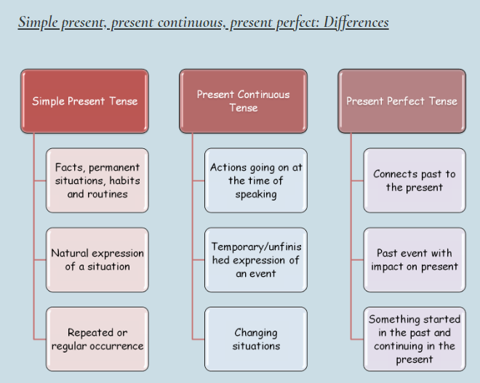
1 việc bắt đầu từ quá khứ vẫn còn tiếp diễn ở hiện tại (6)
Sự thật, tình huống xảy ra vĩnh viễn, thói quen và lộ trình (1)
HTHT
HTTD
HTĐ
Sự kiện quá khứ ảnh hưởng đến hiện tại (5)
Liên kết quá khứ với hiện tại
1 tình huống thay đổi (4)
Biểu đạt 1 sự kiện tạm thời/chưa xong (3)
Hành động xảy ra ở thời điểm nói (2)
Sự việc xảy ra có tần suất lặp đi lặp lại, thường xuyên
biểu đạt tự nhiên một tình huống
Bổ sung bảng trên
(1)  - facts  The moon revolves round the Earth.  - habits and routines  I usually have breakfast before I go to work. | (2),  (3),  (4)  - action happening at the time of speaking  Look! She’s crying.  - temporary action  I’m working as a waitress this summer.  - ongoing changes  The Earth is getting warmer. | (5)  (6)  - one’s experiences /  I’ve never swum in the ocean.  - action that has an effect in the present  He can’t drive. He’s broken his toe.  - action started in the past lasting up to now  She’s lived in London since last year.

Exercise 1
Choose the best present tense to complete these sentences
1. They ______ (go) to the seaside every year but this year they __________ (go) to the mountains.
2. I can’t open the door. I ________ (lose) my key.
3. Who _______ (know) what she ____________ (talk) about? She never __________ (make) any sense.
4. Everybody _________ (know) the world’s rainforests ____________ (disappear).
5. My dress is ruined. What __________ (you, do)?
6. ________ you ________ (see) Laura yet? She ____________ (stay) with us this week while her house ___________ (be) redecorated.
7. More and more people ___________ (become) redundant.
8. I’m sorry, but she ______________ (not, work) today. She _____________ (take) a day off.
9. The sun ____________ (rise) in the east and __________ (set) in the west.
10. Our math teacher usually ___________ (give) us a lot of homework - but not today.
11. People ___________ (get) frustrated with the prices going up every day.
12. Look how well he ____________ (play) today. I _______________ (never, see) him move so fast.
13. This season he ____________ (play) for Liverpool. Who __________ (know) whether he will stay or not?
14. What ______________ (you, do)? Why _____________ (you, lie) in bed? ___________ (I, not, tell) you to tidy up your room?
15. Tom ____________ (sell) his car. _____ you ______ (know) how much he ________ (want) for it?
16. I can’t stand here in the rain. I _________ (get) wet.
17. Listen! Somebody ____________ (play) my favourite song. I __________ (not, hear) it for such a long time.

Exercise 2
Choose Present Simple, Present Continuous or Present Perfect

- Jill _____________________ (water) flowers once a week. Now, she _____________________ (water) flowers. She _____________________ (already/water) all flowers in the living room.
- They _____________________ (just/arrive) from San Francisco. _____________________ (you/ever/be) there? It _____________________ (be) an amazing place!
- They _____________________ (always/produce) so much noise! It is impossible to relax in the evenings!
- _____________________ (not/you/eat) meat? _____________________ (you/be) a vegetarian? Actually, I _____________________ (not/eat) meat every day. I _____________________ (prefer) fish and vegetables.
- Mum _____________________ (already/bake) a cherry pie. We _____________________ (taste) it and it is so delicious!
- Why _____________________ (you/smell) your steak? Has it gone off? (go off: get worse)
- He _____________________ (seem) to be a nice person.
- I _____________________ (understand) what you mean. There is one more solution, though.
- You look so sad. What _____________________ (you/think) about?
- I _____________________ (always/want) to be an artist. But I can’t paint!
- George _____________________ (act) so naturally. He _____________________ (always/be) famous within actors in our country. _____________________ (you/ever/see) his play?
- _____________________ (you/ever/be) to Australia?
- Don’t disturb me, please. I _____________________ (work) on a new project now.
- Our annual meetings _____________________ (be/normally) in spring. But this year we _____________________ (have) them in winter.
- Do you know that Jill _____________________ (find) a new job?
- Jack _____________________ (look) really happy after he _____________________ (pass) his driving test!
- We _____________________ (paint) the walls in our living room.
- He _____________________ (arrive) tomorrow. _____________________ (be/everything) ready? The meeting _____________________ (be) in this room.
- We _____________________ (not/book) a hotel yet. We _____________________ (look) for it now.

THE END
The key

Exercise 1
1. go, are going
2. have lost
3. knows, is talking, makes
4. knows, are disappearing
5. have you done
6. have you seen, is staying, is being
7. are becoming
8. isn’t working, has taken
9. rises, sets
10. gives
11. are getting
12. is playing, have never seen
13. is playing, knows
14. are you doing, are you lying, haven’t I told
15. is selling, do you know, wants
16. am getting
17. is playing, haven’t heard

Exercise 2
- waters-is watering – has already watered
- have just arrived- have you ever been-is
- always produce
- do you not eat-are you-don’t eat-prefer
- has already baked-have tasted
- do you smell
- seems
- understand
- are you thinking
- always want
- acts-always was-have you ever seen
- have you ever been
- am working
- is normally-are having
- has found
- looks-has passed
- have painted
- is arriving-Is everything-is
- havent booked-are looking

